GOVERNMENT KNM ARTS AND SCIENCE COLLEGE
DEPARTMENT OF PHYSICAL EDUCATION
SPORTS REPORT 2020-21
Covid-19 pandemic had disrupted the entire education system including sports; as a result almost most all activities of teaching learning were done in online mode. Sports quota admissions were also done in online mode. The selected students original certificated were verified at the department of physical education by following the coivid protocol and the students were admitted to our college.
Open course (health and fitness education) in physical education for 5th semester students were taken in online mode. Proposal for the purchase of sports items through plan fund was given and sports items for college students were purchased on time. Proposal for starting a new course (Bsc health Fitness and management) were submitted to University of Kerala.

Our students took part in the following kerala university intercollegiate competitions by following the covid protocol and secured the following results.
Sl.No | Name | Participant ID | Event | Position
1 | Rehana Askar | 210088005 | Judo (w) | -
2 | Rohan Satheesh | 210084485 | Power lifting (M) | 66kg -3rd Place
3 | Praveen A B | 21008890 | Power lifting (M) | -
4 | Akhin Varghese | 210088974 | Power lifting (M) | -
5 | Jihith J J | 210087504 | Power lifting (M) | -
6 | Shruthi M suku | 210083321 | Power lifting (w) | -
7 | Sujith Suresh | 210081512 | Wrestling (m) | 74kg-1st Place
8 | Shruthi M suku | 210083321 | Weight lifting (w) | 55kg-1st Place
9 | Jihith J J | 210087504 | Weightlifting (m) | 102Kg-1st Place
10 | Akin Varghese | 210088974 | Power lifting (M) | 73kg-2nd Place

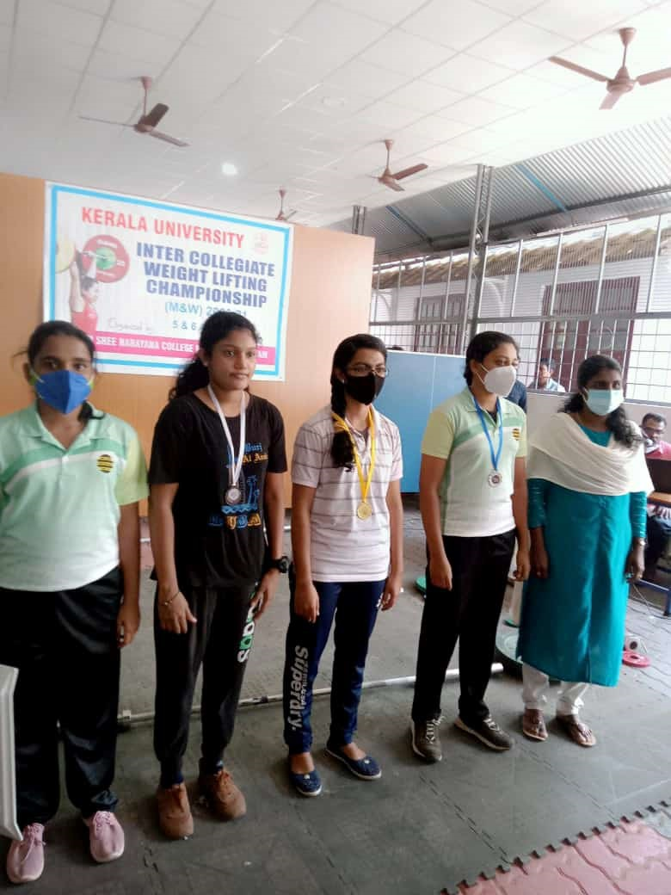
Shruthi M suku – 55 kg weightlifting first at Kerala University Inter-collegiate championship, 2020-21
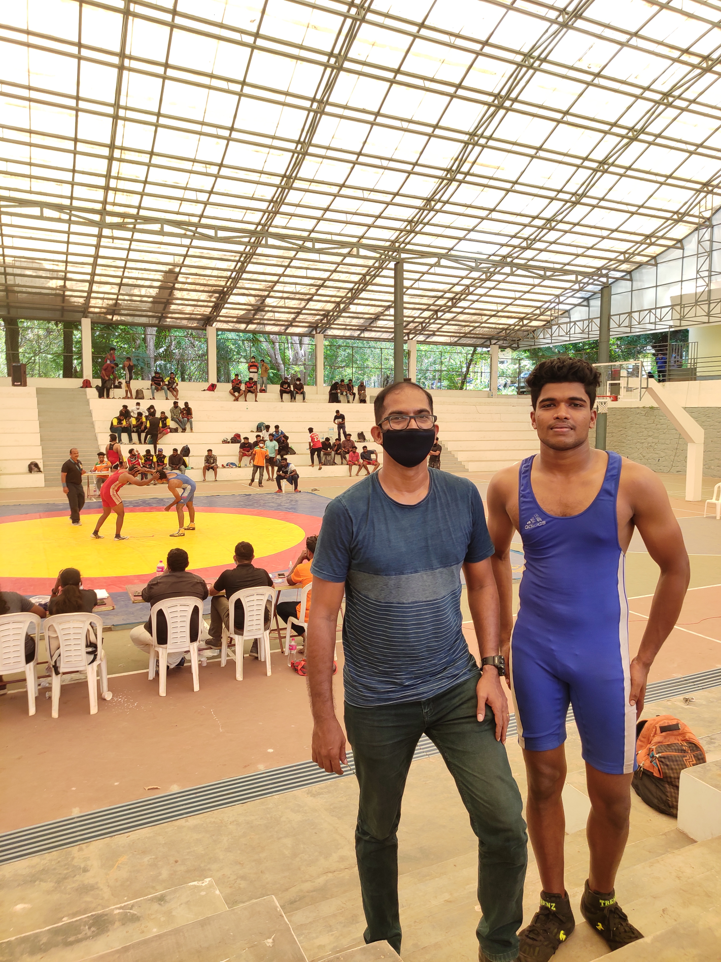
Sujith Suresh - 74Kg wrestling first at Kerala University Inter-collegiate championship 2020-21
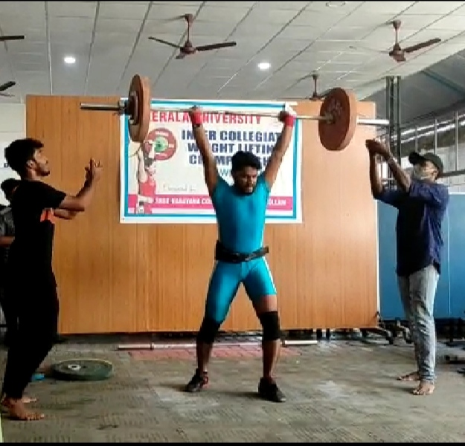
Akhin Varghese -73Kg weightlifting second at Kerala University Inter-collegiate championship 2020-21

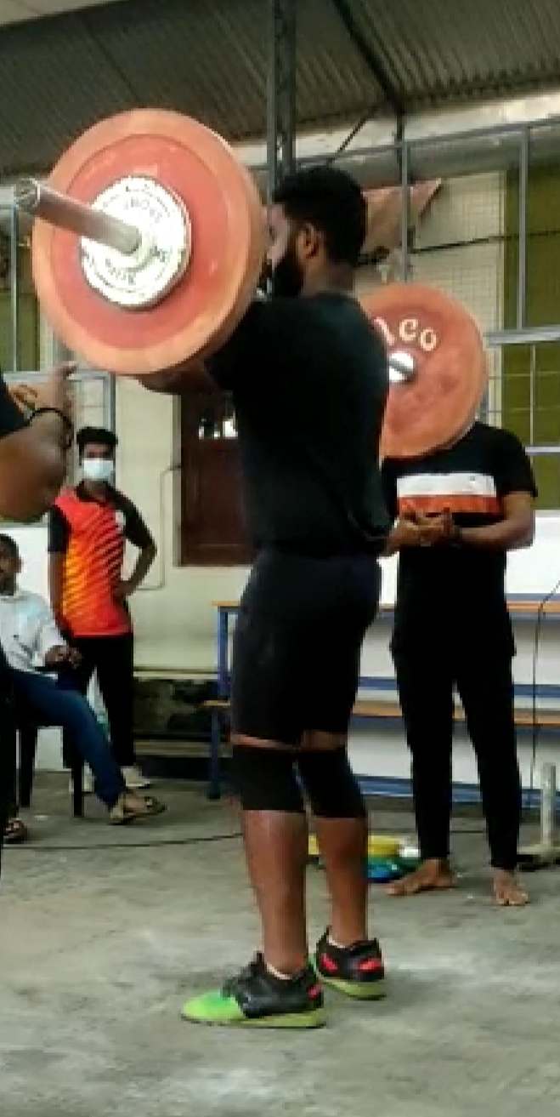
Jihith J J – 102 Kg weightlifting first at Kerala University Inter-collegiate championship 2020-21

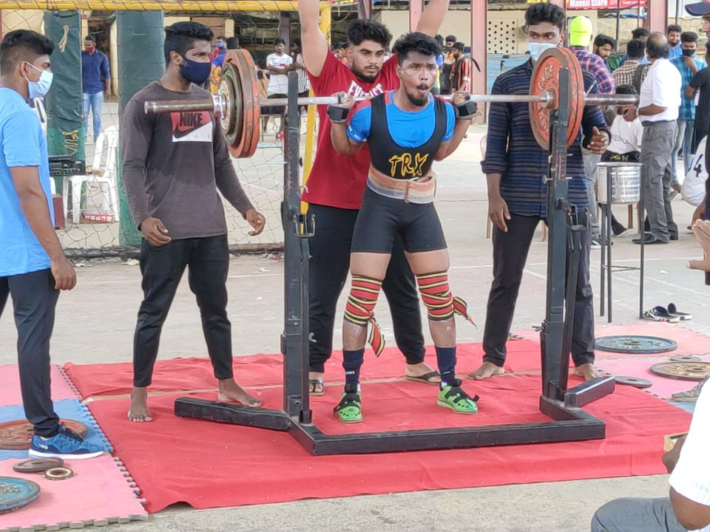
Rohan Satheesh-66kg 3rd place at Kerala University Inter-collegiate championship 2020-21

Power lifting

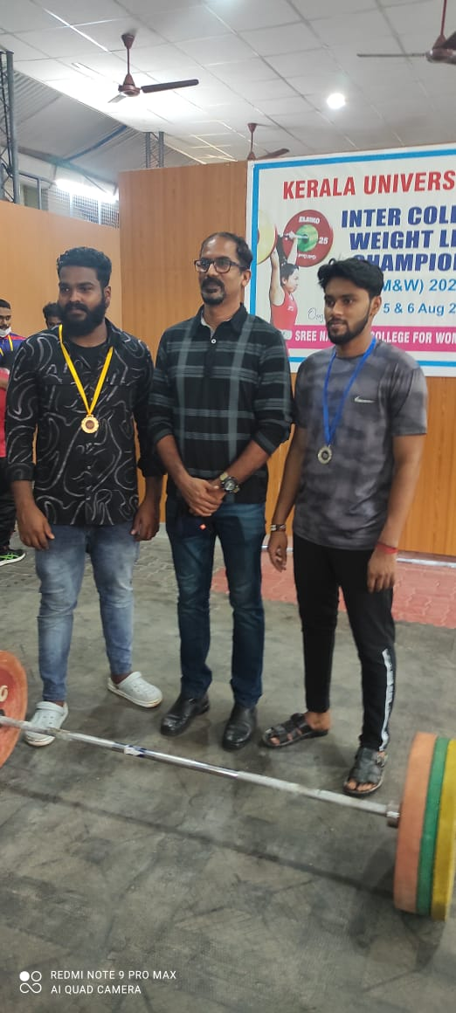
Jihith J J and Akhin Varghese

