CAREER GUIDANCE AND PLACEMENT CELL- 2018-19

Convenor: Krishna.S

Members: Jeeja A.V
Anupama.S.R
Jayasurya.J

REPORTS OF PROGRAMMES CONDUCTED BY CAREER GUIDANCE CELL DURING 2018-19 ACADEMIC YEAR
PROGRAMME 1: MBA SCOPE AND HIGHER STUDIES
An orientation programme on the scope and higher studies in MBA course was held on 29/10/2018 at APJ Hall under the auspices of Career Guidance Cell in collaboration with Narayanaguru College of engineering and Technology, Manjalumoodu. Twenty Eight students of various departments participated in the programme. The class was followed by a quiz competiion as well. Sri Abduraheem.M.P, Assistant Professor of Sociology Department delivered the welcome speech and Ms Anupama, Assistant Professor of English Department delivered the vote of thanks.
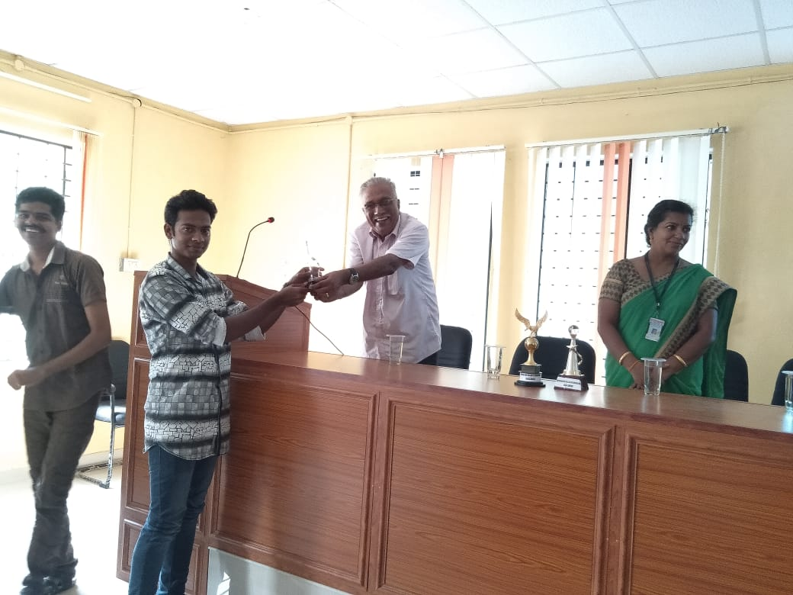

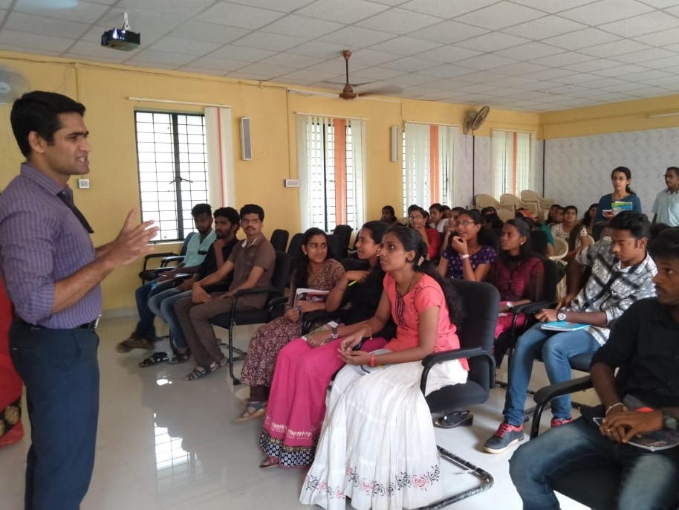

LIST OF PARTICIPANTS
Sl No | Name | Class
FEMALE
 | Roshni B | BA Sociology
 | Asfa Ali | BA Sociology
 | Saranya B R | BA Sociology
 | Vrindha B | BA Sociology
 | Remya M K | BA Sociology
 | Dhanya P | BA Sociology
 | Nithila Raj r S | BA Sociology
 | Aiswarya L R | BA Sociology
 | Farsana N | BA Sociology
 | Anupama MG | B Com
 | Jinsha Raj J | B Com
 | Shyja B M | Bsc Maths
 | Simi S M | Bsc Maths
 | Athira Venugopal | BA Sociology
 | Adithya S john | BA Sociology
 | Supriya D | BA Sociology
 | Saleena Fatheem | BA Sociology
 | Yamuna Venugopal | BA Sociology
 | SandraR S | BA Sociology
 | Rudradas R B | Maths
MALE
 | Vishnu C | Maths
 | Anoop B L | Maths
 | Sivajith S R | Maths
 | Sreenath S | Maths
 | Muhammad Sabith | Maths
 | Praveen G Raj | B Com
 | Abhishek T G | B Com
 | Ananthukrishnan G | B Com

Faculties Participated
Krishna S Dept of Sociology
Abduraheem MP Dept of Sociology
Anupama A V Dept of English
Jayasurya J Dept of Economics
Jeeja A V Dept of Maths

PROGRAMME 2: UPSA-CSAT and OPPURTUNITIES IN SOCIOLOGY
An orientation programme on the scpe of sociology in UPSA- CSAT was held on 30/10/2018 at APJ Hall from 10.00 to 12.00pm, under the auspices of Career Guidance Cell. Smt Remya Roshni, Ex IPS led the session Welcome speech was delivered by Dr Jyothi S Nair, HoD , Dept. of Sociology. Thirty students from various departments both UG and PG and Research Scholars attended the same. Ms Anupama, Assistant Professor of English Department delivered the vote of thanks.
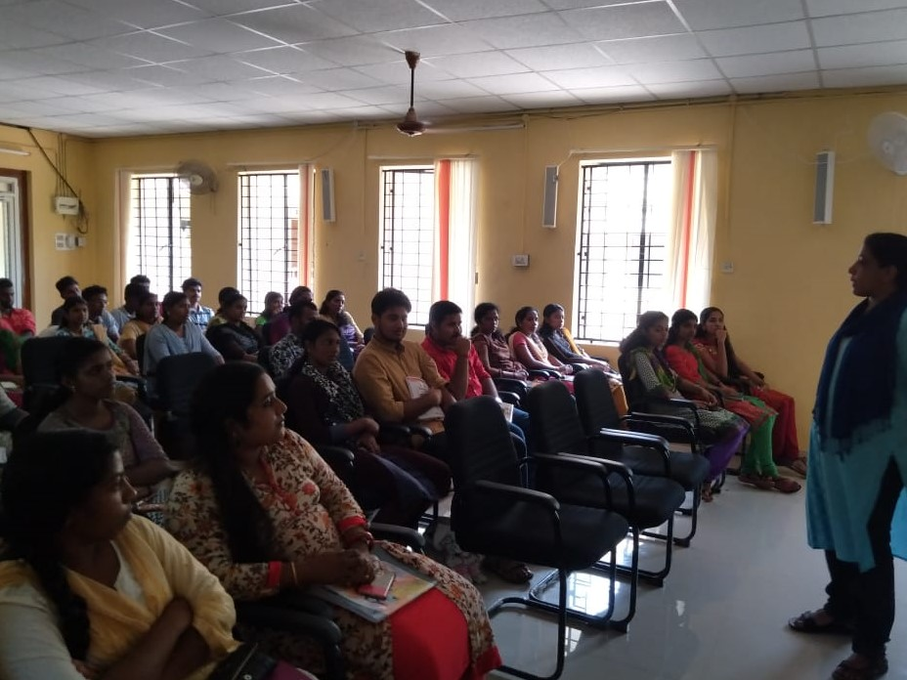
LIST OF PARTICIPANTS
Sl No | Name | Class
FEMALE
 | Soumya madhavan | BA Sociology
 | Anju Ashokan S | BA Sociology
 | Raji Mohan M S | BA Sociology
 | Lidiya V N | BA Sociology
 | Manju K S | BA Sociology
 | Anju L | BA Sociology
 | Gokul G B | BA Sociology
 | Ammu B | MA Sociology
 | Gayathri M S | MA Sociology
 | Sreedhanya B G | MA Sociology
 | Nisha L S | MA Sociology
 | Divya V S | MA Sociology
 | Ammu B | MA Sociology
 | Krishnendhu | MA Sociology
 | Rudrude R B | Bsc Maths
 | Ancy Jerald | BA Sociology
 | Freedamol G | BA Sociology
 | Ramla | BA Sociology
 | Rakhi s R | BA Sociology
 | Noureen A | BA Sociology
 | Aswathy Sreekantan | BA Sociology
 | Veronica Juliane | BA Sociology
 | Fevi William F | BA Sociology
 | Praveena E | BA Sociology
 | Divya M M | Maths
 | Rajalekshmi R | BA Sociology
 | Aswathy M | Maths
 | Simi S M | Maths
 | Mohini G | Research Scholar
Male
 | Anoop B L | Maths
 | Shivajith s r | Maths
 | Rahul Simon | Maths
28 | Sandeep S K | Maths
29.. | Vishnu C | Maths
30 | Sreenath S | Maths

Faculties Participated
Krishna S Dept of Sociology
Abduraheem MP Dept of Sociology
Anupama A V Dept of English
Jayasurya J Dept of Economics
Jeeja A V Dept of Maths

PROGRAMME 3: EMPLOYMENT LINKED SKILL DEVELOPMENT
An orientation programme on ‘Employment Linked Skill was held on 08/11/2018 at APJ Hall from 11.00am to 1.00pm in collaboration with GTEC Computers. The programme designed for final year Degree students was attended by fourty nine students. In this the students got an idea about the various courses that are in demand now in the job market. Many clarified their doubts as well.
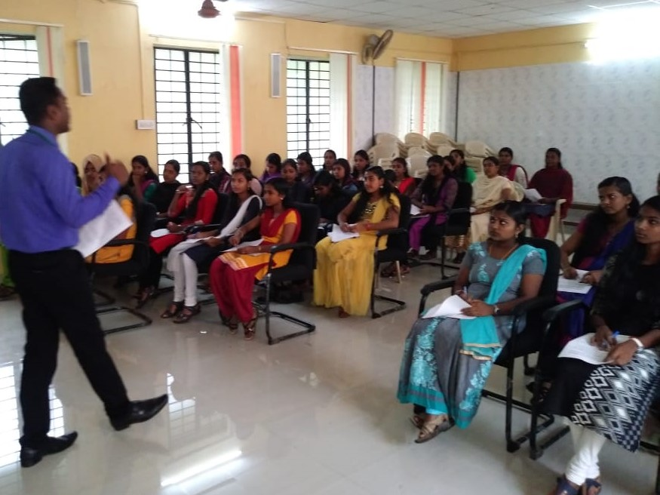

LIST OF PARTICIPANTS
Sl No | Name | Class
FEMALE
 | Soumya S R | BA Economics
 | Alfina H | BA Economics
 | Radhika S A | BA Economics
 | Saranya Sankar | BA Economics
 | Ancy R K | BA Economics
 | Vinila Chandran | BA Economics
 | Arya R S | BA Economics
 | Prijila Ss | BA Economics
 | Priyanka V A | BA Economics
 | Vincy V M | BA Economics
 | Rakhi R S | BA Economics
 | Sruthy B | BA Economics
 | Akhila L B | BA Economics
 | Veronica Julianne | BA Sociology
 | Praveena E | BA Sociology
 | Freedamol G | BA Sociology
 | Aswathy U | BA Sociology
 | Athira S b | BA Sociology
 | Lekshmi U | BA Sociology
 | Arya S Suresh | BA Economics
 | Anju F B | BA Economics
 | Aparna S V | BA Economics
 | Jayaneesha V R | BA Economics
 | Archana A S | BA English
 | Binisha Mol B S | BA English
 | Akhila MM | BA English
 | Keerthy D P | BA Economics
28 | Raji R S | BA Economics
29 | Resmipriya M B | BA Economics
30 | Aswathy B A | BA Economics
31 | Praseetha B S | BA Economics

Faculties Participated
Krishna S Dept of Sociology
Abduraheem MP Dept of Sociology
Anupama A V Dept of English
Jayasurya J Dept of Economics
Jeeja A V Dept of Maths
PROGRAMME 4: SKILL DEVELOPMENT
An orientation programme on the Skill Development for girl students was held on 31/01/2019 at APJ Hall from 2.30am to 3.30pm, under the auspices of Career Guidance Cell in collaboration with Kerala State Womens Development Corporation. Smt Shyni Mathew (Team Leader , REACH Project) explained the programmes offered by their Department, scope and also the admission procedures. It was attended by fourty two girl students.
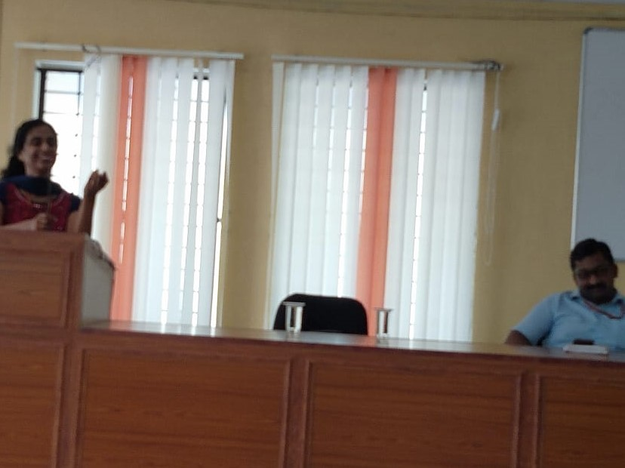
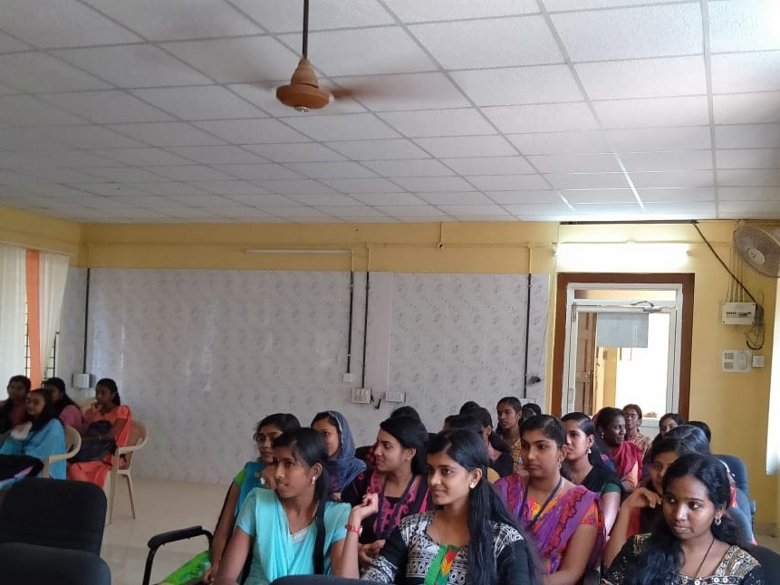

LIST OF PARTICIPANTS
Sl No | Name | Class
FEMALE
 | Saranya S R | BA Sociology
 | Vrindha B | BA Sociology
 | Athira V S | BA Sociology
 | Saleena Fathima | BA Sociology
 | Supriya D | BA Sociology
 | Aswathy U | BA Sociology
 | Aparna s Raj | BA Sociology
 | Lekshmi U | BA Sociology
 | Veronica Juliane | BA Sociology
 | Arlin J S | BA Sociology
 | Aiswarya L R | BA Sociology
 | Reathi M R | BA Sociology
 | Aditya s John | BA Sociology
 | Farsana N | BA Sociology
 | Anjana S | BA Sociology
 | Nithla Raj R S | BA Sociology
 | Aswathy M | BSc Maths
 | Vaishnavi | BSc Maths
 | Simi S M | BSc Maths
 | Shyja B M | BSc Maths
 | Sariga Chandran | BSc Maths
 | Amritha B S | BSc Maths
 | Aksha S Mohan | BSc Maths
 | Athira S M | BSc Maths
 | Geena George | BSc Maths
 | Anjju S | BSc Maths
 | Adhila S | BSc Maths
 | Midhuna Raj | BSc Maths
 | Lakshmi U | BA Sociology
 | Praeena E | BA Sociology
 | Fevi William | BA Sociology
 | Gopika S Kumar | BA Sociology
 | Sabna S Kumar | BA Sociology
 | Amritha rajan | BA Sociology
 | Jincy Wilson | BA Sociology
 | Aparna B | BA Sociology
 | Vijila B S | BA Sociology
 | Teenu R L | BSc Maths
 | Arya U | BA Sociology
 | Soumya B | BA Sociology
 | Feba Anse | BA Sociology
 | Jini G T | BSc Maths

PROGRAMME 5: SCOPE AND JOB OPPURTUNITIES IN ANIMATION AND EDITING AND MULTIMEDIA
An orientation programme on the scope and job opportunities in animation and editing and multimedia was held on 25/03/2019 at Theatre Room of Old Block under the auspices of Career Guidance Cell in collaboration with MAAC Academy of Advanced Cinematics, Trivandrum. Thirty one students of various departments participated in the programme.
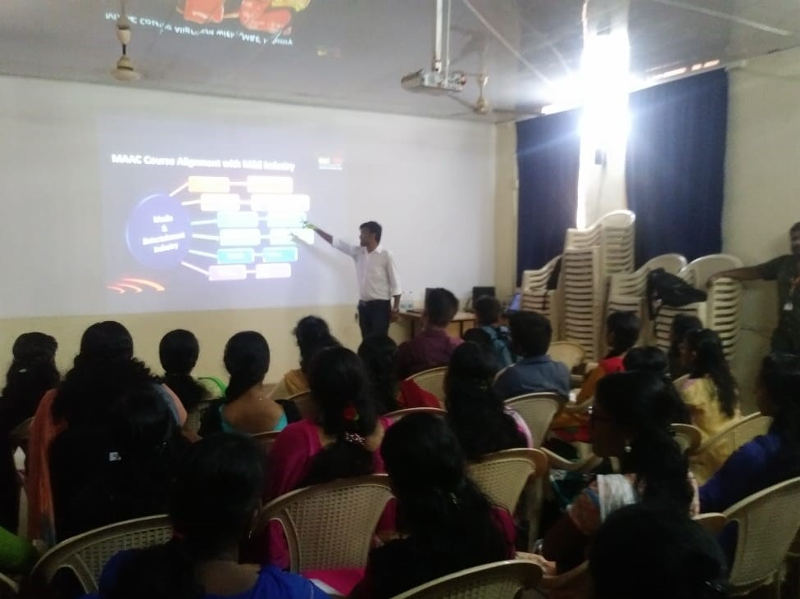
LIST OF PARTICIPANTS
Sl No | Name | Class
FEMALE
 | Salima Sasi | BA Sociology
 | Akhila Raj | BA Sociology
 | Mydhily | BA Sociology
 | Martina | BA Sociology
 | Varsha | BA Sociology
 | Manju | BA Sociology
 | Sangeetha J U | BA English
 | Surya S R | BA English
 | Hima R aravind | BA English
 | Jasmine Mj | BA English
 | Neethu T M | BA English
 | Tino Robinson | BA English

